Technical Report

Carevix: A GenAI-Intelligent Career Guidance Platform


Submitted By

Muhammad Salman
2022-ag-8629

Muhammad Sabtain Ahmad
2022-ag-8635

Advised by

Dr. Rana Muhammad Saleem
Mrs. Sidra Habib

DEPARTMENT OF COMPUTER SCIENCE
FACULTY OF SCIENCES

UNIVERSITY OF AGRICULTURE,
FAISALABAD, PAKISTAN
2025
TITLE: CAREVIX: A GENAI-INTELLIGENT CAREER GUIDANCE PLATFORM

SIGNATURES:

Student

(Muhammad Salman)

Student

(Muhammad Sabtain Ahmad)

EVALUATION COMMITTEE:

- Advisor

(Dr. Rana Muhammad Saleem)

- Advisor

(Mrs. Sidra Habib)

- Member

(Mr. Waqas Ali)

- Member

(Dr. Muhammad Ahmad)

TABLE OF CONTENTS
ABSTRACT 5
CHAPTER 1: INTRODUCTION 5
1.1 Background and Context 5
1.1.1 Evolution of Career Guidance Services 5
1.1.2 Digital Transformation in Education and Career Planning 6
1.1.3 Current Challenges in Career Counselling 6
1.1.4 Market Demand for Intelligent Career Solutions 7
1.1.5 Technological Opportunities and Innovations 7
1.2 Goals and Objectives 7
1.2.1 Primary Goals 7
1.2.2 Educational Alignment Objectives 8
1.2.3 Career Pathway Objectives 8
1.2.4 User Experience Objectives 8
1.2.5 System Integration Objectives 8
1.2.6 Accessibility and Inclusivity Objectives 8
1.2.7 Performance and Reliability Objectives 8
1.2.8 Support and Guidance Objectives 9
1.3 Functional Requirements 9
1.3.1 User Registration and Authentication 9
1.3.2 Profile Management System 9
1.3.3 Assessment Module 9
1.3.4 Recommendation Engine 10
1.3.5 Learning Roadmap Generation 10
1.3.6 Opportunity Matching System 10
1.3.7 Progress Tracking Dashboard 10
1.3.8 Counselling Chatbot 11
1.3.9 Career Transition Support 11
1.3.10 Admin Panel and Management 11
1.3.11 Notification System 11
1.3.12 Resource Library 11
1.4 Non-Functional Requirements 12
1.5 Tools and Technologies 12
CHAPTER 2: SYSTEM ANALYSIS AND DESIGN 13
2.1 Existing System and Problem Analysis 13
2.1.1 Current State of Career Guidance 13
2.1.2 Identified Problems and Limitations 14
2.1.3 User Challenges and Pain Points 14
2.1.4 Technical Stack of Comparable Solutions 15
2.1.5 Gap Analysis 15
2.2 Issues and Limitations of Existing Approaches 15
2.2.1 Manual Career Counselling Limitations 15
2.2.2 Lack of Personalization 15
2.2.3 Insufficient Market Insights 16
2.2.4 Limited Accessibility 16
2.2.5 Scalability Constraints 16
2.2.6 Data Integration Challenges 16
2.3 Proposed System Architecture 16
2.3.1 System Objectives and Vision 16
2.3.2 Key Features and Functionalities 17
2.3.3 System Architecture Overview 17
2.3.4 Technology Stack 17
2.3.5 Security and Privacy Measures 18
2.3.6 Scalability Strategy 18
2.4 Problem Statement 19
2.5 Solution Statement 19
2.5.1 Intelligent Recommendation System 19
2.5.2 Comprehensive Skill Mapping 20
2.5.3 Integrated Opportunity Platform 20
2.5.4 Structured Learning Pathways 20
2.5.5 Real-Time Progress Analytics 20
2.5.6 Career Counselling Chatbot 21
2.5.7 Cross-Platform Compatibility 21
2.6 System Design and User Interface 21
2.6.1 Registration and Login Interface 21
2.6.2 Profile Creation and Management 22
2.6.3 Assessment Module Interface 23
2.6.4 Dashboard and Home Screen 25
2.6.5 Career Path Recommendation View 27
2.6.6 Learning Roadmap Interface 28
2.6.7 Opportunity Listing and Filtering 29
2.6.8 Progress Tracking Dashboard 29
CHAPTER 3: METHODOLOGY AND SYSTEM MODELING 29
3.1 Use Case Diagram and Analysis 29
3.2 Entity-Relationship Diagram 32
3.3 Data Flow Diagram 34
List of Figures

Figure 1: Login Interface 24
Figure 2: Profile Creation 25
Figure 3: Assessment Module Interface 26
Figure 4: Assessment Module Interface 27
Figure 5: Dashboard 28
Figure 6: Home Screen 29
Figure 7: Career Paths 29
Figure 8: Learning Hub 30
Figure 9: Use Case Diagram 32
Figure 10: Entity-Relationship 34
Figure 11: Data Flow Diagram 35

ABSTRACT
The Career Counselling & Guidance web application is designed to address the growing demand for personalized, intelligent, and technology-driven career guidance in today’s highly competitive and rapidly evolving job market. With continuous changes in industry requirements, emerging technologies, and shifting employment trends, students and professionals often face uncertainty when making career-related decisions. This platform aims to bridge the gap between individual potential and market demands by offering a structured, data-driven approach to career planning and development. The system serves a wide range of users, including students, fresh graduates, and working professionals from diverse educational and professional backgrounds. It provides end-to-end support for career exploration, decision-making, and progression. A key feature of the platform is its personalized learning pathways, which guide users toward acquiring the skills and qualifications required for their desired career paths. The system curates educational resources, online courses, certifications, and learning materials, enabling users to upskill and remain competitive. Additionally, the application incorporates real-time opportunity matching, connecting users with relevant internships, job openings, scholarships, and professional development opportunities based on their profiles and progress.From a technical perspective, the application is developed using React.js for the frontend to ensure a responsive, intuitive, and user-friendly interface. The backend is implemented using Node.js with Express.js, enabling efficient server-side operations, API handling, and business logic implementation. MongoDB is used for data persistence due to its flexibility and scalability, making it suitable for handling dynamic user profiles and career data. The system architecture prioritizes scalability, security, and reliability, ensuring safe data handling and smooth performance under increasing user load.

GANTT CHART
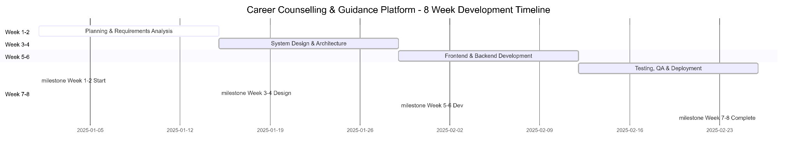

CHAPTER 1:

1.1 Introduction and Background

1.1.1 Evolution of Career Guidance Services
Career guidance has undergone significant transformation over the past two decades. Traditional career counselling, conducted through face-to-face consultations in educational institutions and career centers, has long served as the primary avenue for career-related advice. These conventional approaches, while valuable, often suffered from limited accessibility, geographical constraints, and the inability to serve large populations simultaneously. The evolution began with telephone-based services, which expanded the reach of career counsellors but still maintained inherent limitations in terms of service capacity and scalability.
The progression from traditional to digital career guidance services marked a turning point in the industry. Early digital solutions emerged primarily as informational websites providing job listings and educational program databases. However, these platforms lacked the personalization and intelligent matching capabilities that modern users require. The fundamental shift occurred when educational institutions and career service providers recognized the potential of technology to enhance and democratize access to quality career guidance.

1.1.2 Digital Transformation in Education and Career Planning
The digitalization of educational services has fundamentally changed how individuals approach career planning. Educational institutions now rely heavily on digital platforms for student engagement, and career guidance represents a natural extension of this ecosystem. The integration of learning management systems, skills assessment tools, and job market data into unified platforms has created opportunities for more informed decision-making by students and professionals alike.
Universities, particularly specialized institutions like agricultural universities, face unique challenges in connecting their graduates with relevant career pathways. Students from niche educational backgrounds often struggle to identify how their specialized knowledge translates into diverse career opportunities. Digital transformation enables these institutions to provide targeted guidance that bridges the gap between academic learning and professional application.

1.1.3 Current Challenges in Career Counselling
Despite the availability of digital resources, significant challenges persist in the career counselling landscape. Many graduates, particularly from specialized programs, lack awareness of relevant career opportunities that align with their expertise. The sheer volume of available career paths, combined with rapidly evolving job market demands, makes manual guidance increasingly insufficient. Additionally, the shortage of qualified career counsellors relative to the student population creates bottlenecks in service delivery.
Career transition for professionals seeking to switch industries or roles presents another layer of complexity. Individuals lack clear guidance on skill gaps, required learning paths, and transition strategies specific to their situations. The absence of personalized, data-driven recommendations often leads to poor career decisions and inefficient resource allocation toward upskilling.

1.1.4 Market Demand for Intelligent Career Solutions
The job market's rapid evolution has created significant demand for intelligent solutions that can provide real-time insights into industry trends and skill requirements. Employers report increasing difficulty in identifying candidates with appropriate skill combinations, while job seekers struggle to understand what qualifications are actually needed for various positions. This mismatch creates inefficiency in both talent acquisition and career development processes.
The COVID-19 pandemic accelerated the adoption of digital career guidance tools, demonstrating the necessity for accessible, remote-friendly career support systems. Organizations recognized that traditional counselling models could not scale to meet the demand for career guidance, particularly among remote and distributed workforces. Contemporary career guidance solutions must address this broader market need by providing technology-enabled, scalable alternatives to traditional counselling.

1.1.5 Technological Opportunities and Innovations
Recent advances in artificial intelligence and machine learning have created unprecedented opportunities for delivering personalized career guidance at scale. Recommendation algorithms, when properly trained on career development data, can identify career paths and skill requirements with considerable accuracy. Natural language processing enables the development of conversational interfaces that can provide immediate, contextual career guidance to users.
The availability of comprehensive job market data, educational resource libraries, and opportunity databases provides the foundation for intelligent matching systems. Integration of these diverse data sources into cohesive platforms allows for sophisticated analysis of individual strengths, interests, and career aspirations against market realities. Furthermore, modern cloud infrastructure enables the deployment of scalable solutions that can serve large user populations without performance degradation.

1.2 Goals and Objectives

1.2.1 Primary Goals
The Career Counselling & Guidance platform aims to deliver comprehensive, personalized career guidance to students and professionals at scale. The primary goal is to eliminate the traditional bottlenecks in career counselling by providing intelligent, technology-enabled solutions that adapt to individual learning styles, career aspirations, and market conditions. The system strives to empower users with knowledge, resources, and opportunities necessary to make informed career decisions and pursue sustainable career development.

1.2.2 Educational Alignment Objectives
The application will align users' educational backgrounds and specialized knowledge with corresponding career opportunities. For students from agricultural universities and other specialized institutions, the system will identify diverse pathways where their expertise remains valuable. The platform will maintain an updated repository of educational resources, certifications, and upskilling programs that enable users to address skill gaps and transition into new domains.

1.2.3 Career Pathway Objectives
The system will generate comprehensive career roadmaps that extend from entry-level positions through advanced professional roles. Each pathway will include sequential skill development stages, recommended projects, relevant certifications, and timelines for achievement. The application will support exploration of multiple career trajectories, allowing users to compare options and understand the implications of different career choices.

1.2.4 User Experience Objectives
The platform will deliver an intuitive, accessible user interface that accommodates users with varying levels of technical proficiency. All recommendations will be presented in clear, actionable formats with supporting explanations that help users understand the reasoning behind specific suggestions. The system will minimize cognitive load through progressive disclosure of information and personalized experiences based on user preferences and interaction history.

1.2.5 System Integration Objectives
The application will seamlessly integrate multiple data sources including job market information, educational resources, opportunity databases, and user assessment results. API integrations with external platforms will provide real-time data on internship opportunities, scholarship programs, and industry events. This comprehensive integration creates a unified ecosystem where users can access all necessary career guidance resources within a single platform.

1.2.6 Accessibility and Inclusivity Objectives
The system will support users from diverse backgrounds, educational levels, and career stages. Accessibility features will ensure the platform is usable by individuals with various disabilities, while support for multiple languages can accommodate international user bases. The platform will avoid bias in recommendation algorithms by regularly auditing results and incorporating diversity considerations into system design.

1.2.7 Performance and Reliability Objectives
The application will deliver recommendations within acceptable timeframes, with typical responses loading within three to five seconds. The system will maintain high availability, targeting 99% uptime to ensure users can access career guidance whenever needed. Automatic backup systems will protect user data and ensure recovery from potential system failures without data loss.

1.2.8 Support and Guidance Objectives
An embedded conversational AI chatbot will provide continuous, immediate support for user questions and concerns related to career development. The chatbot will escalate complex queries to human counsellors when necessary while handling routine inquiries independently. Human expert validation of recommendations will ensure that system suggestions align with current market realities and professional practices.

1.3 Functional Requirements

1.3.1 User Registration and Authentication
The system will support secure user registration through email-based account creation with password protection. Alternative authentication methods including social media login and institutional credentials will be available to enhance convenience. The authentication module will implement industry-standard security practices including password hashing, secure session management, and protection against common attacks such as SQL injection and cross-site scripting. Users will have the ability to manage authentication settings including two-factor authentication, password recovery, and account security preferences.

1.3.2 Profile Management System
Users will create comprehensive profiles containing personal information, educational background, work experience, skills, and career aspirations. The profile system will support progressive completion, allowing users to add information gradually without requiring immediate full disclosure. Profile data will include fields for educational qualifications, certifications, languages spoken, technical competencies, soft skills, work experience history, and career preferences. Users will maintain control over profile visibility, determining what information is shared publicly versus kept private for personal use only.

1.3.3 Assessment Module
The assessment component will deliver interactive questionnaires designed to evaluate user interests, aptitudes, learning styles, and career preferences. The system will administer scientifically-validated assessment instruments that provide reliable insights into user characteristics relevant to career decision-making. Assessment results will be presented through intuitive reports with visualizations that help users understand their profile relative to different career domains. The module will support reassessment over time to track evolving interests and aptitudes as users progress through their careers.

1.3.4 Recommendation Engine
An intelligent recommendation system will analyze user profiles, assessment results, and market data to generate personalized career suggestions. The engine will employ machine learning algorithms to identify career paths that align with user skills, interests, and educational backgrounds. The system will provide ranked recommendations with confidence scores and explanations that help users understand why specific careers are suggested. The recommendation engine will continuously learn from user interactions and feedback to improve accuracy and relevance over time.

1.3.5 Learning Roadmap Generation
The system will create detailed learning roadmaps that outline the sequential steps required to transition from a user's current state to target career roles. Roadmaps will include specific skills to develop, recommended courses and certifications, projects to undertake, estimated timelines, and success metrics. The platform will curate learning resources including online courses, books, tutorials, and hands-on projects from reputable providers. Roadmaps will remain flexible, allowing users to customize sequences based on their pace and preferences while maintaining strategic coherence.

1.3.6 Opportunity Matching System
The platform will identify and present relevant opportunities including internships, scholarships, open-source programs, hackathons, freelance projects, and entry-level positions. The matching system will filter opportunities based on user skills, career stage, interests, and geographic preferences. Detailed opportunity information will include application deadlines, requirements, expected outcomes, and links to official sources. The system will facilitate direct applications through integrated submission interfaces where possible.

1.3.7 Progress Tracking Dashboard
A comprehensive dashboard will display user progress toward career development goals including completion of learning modules, skill acquisitions, and project completions. The system will provide visual representations of progress through charts, timelines, and milestone tracking. Users will receive reminders and notifications about upcoming learning activities, application deadlines, and skill development checkpoints. Historical progress data will enable users to understand their trajectory and celebrate achievements.

1.3.8 Counselling Chatbot
An AI-powered conversational interface will provide immediate responses to user questions about careers, skill development, and opportunity navigation. The chatbot will understand context from user profiles and previous interactions to deliver personalized advice. Natural language processing capabilities will enable the system to handle diverse question formats and provide thoughtful responses even to unanticipated queries. The chatbot will escalate complex or sensitive matters to human counsellors through integrated communication channels.

1.3.9 Career Transition Support
The system will offer specialized support for users seeking to transition between industries or career fields. Gap analysis tools will identify skill deficiencies relative to target roles, while bridge course recommendations will suggest efficient pathways to address gaps. Industry insight modules will help users understand cultural and practical differences between their current and target career domains. Mentorship matching will connect transition-seeking users with professionals who have successfully navigated similar transitions.

1.3.10 Admin Panel and Management
Administrative interfaces will enable platform administrators to manage system content including skills databases, resource libraries, opportunity catalogs, and user data. The admin panel will provide tools for monitoring system performance, user statistics, and platform usage patterns. Administrators will manage user accounts, handle support escalations, and maintain platform integrity. Content management tools will simplify the addition and updating of resources, ensuring the platform remains current with evolving market conditions.

1.3.11 Notification System
A comprehensive notification framework will deliver timely alerts regarding opportunity deadlines, skill development reminders, learning module completion prompts, and personalized career recommendations. Users will customize notification preferences including frequency, delivery channels, and content types. The system will send notifications through multiple channels including in-app messages, email, and push notifications where applicable. Notification intelligence will avoid overwhelming users while ensuring important information reaches them promptly.

1.3.12 Resource Library
A curated digital library will provide access to educational materials, career guides, industry reports, and professional development resources. The resource library will include video tutorials, comprehensive articles, downloadable templates, and interactive tools. Resources will be organized through multiple classification systems including subject matter, target audience, difficulty level, and learning style. Quality assessment mechanisms will ensure that recommended resources meet professional standards and provide genuine value to users.

1.4 Non-Functional Requirements
The application must maintain responsive performance across all user interactions, with recommendations and assessments loading within three to five seconds under typical load conditions. The system will be designed for seamless operation across desktop and mobile platforms with adaptive layouts that optimize display on various screen sizes. Security implementations will include secure authentication mechanisms, encrypted storage of sensitive personal information, and compliance with data protection regulations. The architecture will support growth in user base and data volume without requiring major redesign or experiencing performance degradation. Usability standards will ensure that individuals with varying technical proficiency can effectively navigate the platform. The system will implement comprehensive error handling, graceful degradation during partial outages, and automated recovery mechanisms. Modular code organization will facilitate maintenance, bug fixes, and future enhancements without affecting existing functionality. The platform will generate detailed logs of all system activities for debugging and audit purposes while maintaining user privacy.

1.5 Tools and Technologies
Frontend Development: React.js and Next.js frameworks provide robust foundations for building responsive, interactive user interfaces. TailwindCSS enables efficient styling with utility-first design patterns that maintain consistency across the application.
Backend Development: Node.js runtime with Express.js framework handles server-side logic, API development, and request processing. Python with scikit-learn and TensorFlow will support machine learning algorithms for the recommendation engine and assessment analytics.
Database Management: MongoDB provides flexible, scalable document storage suitable for diverse user profiles and assessment data. The NoSQL approach accommodates evolving data structures as system requirements mature.
Version Control: Git and GitHub facilitate collaborative development, code review, and version management across the team.
Development Environments: Visual Studio Code and Cursor offer feature-rich editing environments with extensions for debugging, linting, and code formatting. Android and iOS emulators enable testing across mobile platforms.
Testing Frameworks: Jest and React Testing Library support unit and integration testing of frontend components. Backend testing employs Mocha and Chai frameworks alongside Postman for API testing.
Deployment Infrastructure: Amazon Web Services provide cloud hosting with EC2 for application servers, S3 for file storage, and RDS for database management. AWS Lambda enables serverless execution of notification and background processing tasks.
API Integration Tools: Axios and Fetch API handle communication between frontend and backend services. GraphQL may be employed for certain complex data query requirements.
Security Tools: bcrypt library secures password storage through hashing and salting. JWT (JSON Web Tokens) manages authentication tokens. CORS middleware controls cross-origin requests. Environment variables secure sensitive configuration data.

CHAPTER 2:

2.1 Existing System and Problem Analysis

2.1.1 Current State of Career Guidance
Contemporary career guidance exists across multiple fragmented channels including educational institution career offices, private counselling services, online job portals, and informal mentoring relationships. Educational institutions typically employ career counsellors who serve large student populations, creating capacity constraints that limit personalized attention. Many students, particularly in specialized fields like agriculture, struggle to find counsellors with domain-specific knowledge relevant to their career aspirations.
Online career guidance platforms have emerged, yet many function primarily as job listing aggregators without providing deeper career development support. These platforms often lack assessment capabilities, personalized roadmap generation, and comprehensive learning resource curation. The absence of intelligent matching between user profiles and opportunities results in overwhelming information volumes that complicate decision-making rather than facilitating it. Manual systems for opportunity dissemination fail to keep pace with the rapid emergence of new opportunities, scholarships, and programs.

2.1.2 Identified Problems and Limitations
Educational institutions struggle to effectively communicate the breadth of career opportunities available to their graduates, particularly those from specialized programs. Graduates from agricultural universities, for instance, often perceive their career options as narrowly limited to agricultural sectors, unaware of how their training applies across diverse industries. The absence of structured frameworks for exploring transferable skills leaves many graduates underutilizing their educational investments.
Current career counselling approaches rely heavily on manual processes involving scheduled appointments, limited availability, and geographic constraints. This model proves inadequate for serving geographically dispersed populations, working professionals, or individuals needing guidance outside standard business hours. Students from underprivileged backgrounds or remote areas face particular barriers in accessing professional career guidance, leading to disadvantaged career outcomes.
The lack of data-driven insights into evolving job market requirements creates misalignment between skill development emphasis in educational curricula and actual market demands. Graduates often discover too late that their acquired skills inadequately prepare them for preferred career paths, necessitating costly and time-consuming additional training.

2.1.3 User Challenges and Pain Points
Students experience anxiety regarding career decisions due to limited information about realistic career options, skill requirements, and transition pathways. Graduates struggle to articulate how their educational background translates into market-relevant competencies, making professional networking and job applications less effective. Professionals seeking career transitions lack structured methodologies for assessing transferability of existing skills and identifying efficient upskilling approaches.
The abundance of available online resources creates choice paralysis, with individuals unable to prioritize what to learn given resource constraints. Educational content quality varies substantially, with no systematic means of identifying genuinely valuable resources from less effective ones. Individuals pursuing career changes frequently invest in expensive certifications or training programs that fail to deliver promised career advancement, resulting in wasted time and financial resources.

2.1.4 Technical Stack of Comparable Solutions
Existing career guidance platforms employ varying technological approaches with different effectiveness levels. Some utilize simple database systems for job listings, while others have begun incorporating machine learning for recommendation functions. Major platforms like LinkedIn employ sophisticated neural network approaches for job recommendations, though these generally focus on matching with available positions rather than holistic career development. Cloud infrastructure has become standard, though implementation maturity varies.

2.1.5 Gap Analysis
Current market solutions fail to provide integrated platforms addressing the full spectrum of career development needs. Existing systems typically specialize in single functions such as job matching, learning content delivery, or skills assessment, without unifying these services. The absence of platforms specifically designed for specialized graduate populations creates unmet needs in institutions like agricultural universities. Few solutions provide comprehensive support for career transitions with explicit gap analysis and bridge pathway recommendations.

2.2 Issues and Limitations of Existing Approaches

2.2.1 Manual Career Counselling Limitations
Traditional in-person career counselling, despite its interpersonal benefits, cannot serve populations at the scale required by contemporary educational institutions and labor markets. The time investment required for comprehensive career counselling by qualified professionals creates inherent supply constraints.

2.2.2 Lack of Personalization
Generic career guidance resources fail to account for individual variations in learning styles, pace preferences, and career stage requirements. One-size-fits-all approaches prove ineffective for heterogeneous user populations with diverse backgrounds and aspirations. Recommendation systems in existing platforms often employ simplistic matching algorithms based on job titles or keywords, missing nuanced connections between individual capabilities and appropriate career paths.

2.2.3 Insufficient Market Insights
Career guidance systems lack real-time integration of evolving job market data, skill demand trends, and emerging industry sectors. Static databases become outdated rapidly, leading to recommendations misaligned with current market realities. The absence of data on successful skill-to-career transitions leaves guidance recommendations lacking empirical grounding. Industry insights often reflect broad generalities rather than specific, actionable intelligence relevant to individual decisions.

2.2.4 Limited Accessibility
Geographic dispersion, time zone differences, and varying physical abilities create barriers to traditional career counselling services. The absence of 24/7 guidance support means that individuals outside standard business hours lack immediate access to career advice. Mobile optimization remains insufficient in many existing platforms, limiting usability for individuals relying primarily on smartphone access.

2.2.5 Scalability Constraints
As user populations grow, manual career counselling services face capacity limitations that prevent serving all interested individuals. Database systems in legacy platforms often encounter performance degradation with increasing data volumes. Recommendation engine performance degrades significantly when serving large populations, making real-time personalized guidance impractical for platforms with large user bases.

2.2.6 Data Integration Challenges
Career guidance requires integration of diverse data sources including educational program catalogs, job postings, skill requirement databases, and individual user profiles. Technical and administrative challenges in integrating these disparate sources limit the comprehensiveness of guidance provided. Legacy systems employed by educational institutions often fail to interoperate with modern career guidance platforms, creating barriers to seamless information flow.

2.3 Proposed System Architecture

2.3.1 System Objectives and Vision
The Career Counselling & Guidance platform will deliver scalable, intelligent, personalized career guidance accessible to diverse user populations. The system vision encompasses creating a unified ecosystem where individuals find comprehensive support for all aspects of career development, from initial exploration through professional advancement. By combining assessment methodologies, machine learning recommendations, structured learning pathways, and opportunity matching, the platform will democratize access to high-quality career guidance previously available only to privileged populations with access to professional counsellors.

2.3.2 Key Features and Functionalities
The platform will deliver intelligent recommendations through advanced algorithms analyzing user profiles against market data. Comprehensive learning roadmaps will guide progression toward career goals with specific, actionable steps. Real-time opportunity matching will surface internships, scholarships, and jobs aligned with user interests and capabilities. An integrated conversational AI chatbot will provide immediate responses to routine career questions. Progress tracking tools will help users monitor advancement toward goals and remain motivated through visual representations of achievement.

2.3.3 System Architecture Overview
The system employs a client-server architecture with clear separation between frontend user interfaces, backend business logic, and data persistence layers. The frontend layer delivers responsive web and mobile interfaces through React and Next.js frameworks. The backend layer implements business logic through Node.js and Express, managing authentication, recommendation generation, user data processing, and third-party integrations. The data layer persists user information, assessments, resources, and system data in MongoDB. Machine learning components implemented in Python handle algorithm training and inference for recommendation generation.

2.3.4 Technology Stack
Frontend: React.js with Next.js; TailwindCSS; Redux; Axios for HTTP requests; Chart.js for analytics visualization; Socket.io for real-time notifications.
Backend: Node.js with Express.js; Python with Flask for ML services; JWT for authentication; bcrypt for password encryption.
Database: MongoDB Atlas for scalable cloud hosting; Redis for caching and session management.
AI/ML: Scikit-Learn for recommendation algorithms; TensorFlow for neural network models; spaCy for natural language processing; Pandas for data manipulation.
Testing: Jest for unit testing; Supertest for API testing; Selenium for UI automation.
DevOps: Docker for containerization; Kubernetes for orchestration; GitHub Actions for CI/CD; AWS CloudWatch for monitoring.
Cloud Infrastructure: AWS EC2 for compute; AWS RDS for managed databases; AWS S3 for file storage; CloudFront for CDN; Lambda for serverless functions.

2.3.5 Security and Privacy Measures
The system implements multiple layers of security protecting sensitive user information and maintaining platform integrity.
Authentication: JWT-based token authentication; multi-factor authentication for sensitive operations; secure password hashing with bcrypt; session timeout mechanisms.
Encryption: End-to-end encryption for data transmission using HTTPS/TLS; encrypted storage of sensitive information at rest; encrypted database fields for personally identifiable information.
Authorization: Role-based access control limiting functionality based on user types (regular user, premium user, admin); field-level permissions ensuring users access only appropriate data.
Data Privacy: GDPR compliance for user data handling; explicit consent mechanisms; comprehensive privacy policies; user rights for data access, modification, and deletion.
Security Audits: Regular vulnerability assessments; penetration testing; dependency scanning for vulnerable libraries; security update protocols.
Compliance: Adherence to FERPA guidelines for educational data; COPPA compliance for underage users where applicable; data retention policies preventing indefinite storage.

2.3.6 Scalability Strategy
The system architecture supports growth through multiple mechanisms:
Horizontal Scaling: Containerized microservices enabling independent scaling based on demand; load balancers distributing traffic across multiple instances.
Database Optimization: MongoDB's distributed architecture supporting sharding; indexing strategies optimizing query performance; query optimization reducing computational overhead.
Caching Strategy: Redis caching frequently accessed data reducing database load; CDN distribution serving static assets globally; application-level caching minimizing redundant computations.
Asynchronous Processing: Message queues handling time-consuming operations asynchronously preventing blocking; job scheduling for batch processing during off-peak hours.
API Rate Limiting: Throttling mechanisms preventing abuse and ensuring fair resource distribution; quota management for API endpoints.

2.4 Problem Statement
Students and early-career professionals face significant challenges in making informed career decisions due to fragmented, impersonal career guidance systems. Many individuals, particularly from specialized educational backgrounds like agricultural universities, struggle to identify career paths aligned with their skills and interests while remaining unaware of relevant opportunities in their fields. Traditional career counselling services offer limited accessibility due to geographic constraints and restricted availability, while existing digital platforms operate in isolation without comprehensive integration. Current systems fail to provide personalized recommendations considering individual learning styles, skill levels, and career aspirations, resulting in generic guidance applicable to few users. The disconnect between academic preparation and market demands creates uncertainty for graduates transitioning to professional roles. Career transitioners seeking mid-career changes lack specialized support identifying transferable skills and planning realistic transitions. Existing opportunity platforms do not connect with assessment and learning systems, requiring users to manually search for positions without contextual guidance. The absence of real-time progress tracking prevents users from visualizing their skill development and remaining motivated. Without comprehensive career guidance ecosystems, many capable individuals make suboptimal career decisions, resulting in job dissatisfaction, career stagnation, and underutilization of talent within the economy (Li et al., 2020; Madinga et al., 2023).

2.5 Solution Statement
The Career Counselling and Guidance system addresses documented challenges through comprehensive integration of assessment, learning, opportunity discovery, and progress tracking into a unified ecosystem. The solution prioritizes personalization, accessibility, and real-time engagement while supporting diverse career trajectories and learning preferences.

2.5.1 Intelligent Recommendation System
Advanced machine learning algorithms analyze assessment results, skill inventories, educational backgrounds, and market data to generate personalized career path recommendations. The recommendation engine considers multiple variables including skill-interest alignment, educational prerequisites, salary expectations, job market demand, and employment growth projections. Multiple career pathways are presented with realistic progression timelines, branching possibilities, and prerequisite skill requirements. The system continuously learns from user interactions and outcomes, refining recommendations as users progress through development stages (Misra et al., 2020).

2.5.2 Comprehensive Skill Mapping
Multi-dimensional skill assessment evaluates technical competencies, soft skills, personality indicators, and learning preferences through interactive questionnaires, practical exercises, and portfolio analysis. Assessment results map individual capabilities against industry-standard skill frameworks, identifying strengths, development areas, and latent capabilities. The system recognizes transferable skills applicable across career transitions, providing transitioners with concrete evidence of relevant competencies. Skill proficiency levels are tracked continuously as users complete learning activities, creating dynamic capability profiles reflecting actual demonstrated competencies rather than self-reported estimates (Bhatti and Alawad, 2024).

2.5.3 Integrated Opportunity Platform
Seamless integration with multiple opportunity sources including internship platforms (Internshala, LinkedIn), scholarship databases, hackathon registries, open-source program listings, and job boards creates unified opportunity access. The matching algorithm connects users with opportunities aligned to their current capabilities and career stage, preventing both underqualification frustration and overqualification boredom. Real-time notifications alert users to new opportunities matching their profiles, ensuring timely awareness of time-sensitive offerings. Opportunity discovery encourages practical experience accumulation supporting career development beyond classroom learning (Peng et al., 2024).

2.5.4 Structured Learning Pathways
Personalized learning roadmaps organize educational resources into sequential progressions addressing identified skill gaps and supporting selected career paths. Roadmaps incorporate user learning style preferences, estimated time availability, and prior knowledge levels, creating realistic learning sequences. Resources from multiple platforms including Coursera, Udemy, LinkedIn Learning, and open-source documentation are curated and organized into coherent pathways. Learning milestones with skill checkpoints and project-based assessments enable users to validate acquired capabilities. Adaptive algorithms adjust pathway recommendations based on user progress, learning speed, and emerging skill demands (Ashish et al., 2024).

2.5.5 Real-Time Progress Analytics
Comprehensive dashboards visualize skill development trajectories, learning activity completion, milestone achievements, and progress toward career goals. Analytics employ multiple visualization perspectives including skill progression graphs, timeline tracking, competency heatmaps, and goal achievement indicators. Users understand their development rates, identify areas requiring additional focus, and celebrate achievements sustaining motivation. Analytics inform personalized recommendations for continued progression, identifying next logical skill acquisitions or opportunities matching emerging capabilities. Data-driven insights help users make informed decisions about pathway adjustments and opportunity selections (Mathur and Arora, 2020).

2.5.6 Career Counselling Chatbot
An AI-powered conversational interface provides 24/7 availability for career-related questions, guidance on specific topics, and emotional support during decision-making processes. The chatbot understands user context including assessment results, learning progress, and career goals, enabling genuinely personalized responses rather than generic scripted answers. Natural language processing enables conversational interaction feeling supportive and empathetic rather than robotic. The system escalates complex queries to human counsellors while handling routine questions independently, optimizing resource allocation. Users engage with the chatbot across platforms and devices, ensuring consistent support availability regardless of time or location constraints (Capito and Pergelova, 2023).

2.5.7 Cross-Platform Compatibility
Responsive design ensures seamless user experience across desktop computers, tablets, and smartphones without requiring platform-specific applications. Progressive web application technology enables offline functionality for essential features, ensuring accessibility even without internet connectivity. Consistent user experience across devices encourages continuous engagement regardless of users' current location or available devices. Cross-platform accessibility particularly benefits international students and professionals in regions with varying technology availability (Podobed, 2024).

2.6 System Design and User Interface
The Career Counselling and Guidance system interface prioritizes intuitive navigation, clear information hierarchy, and engaging visual design supporting user motivation throughout career development journeys.

2.6.1 Registration and Login Interface
Clean, minimalist registration interface captures essential information including name, email, educational background, and career stage. Multi-step registration breaks complex data collection into manageable sections, reducing form abandonment. Password strength indicators encourage secure credential creation. Optional social login through Google and LinkedIn enables rapid account creation for users with existing professional profiles. Login interface maintains simplicity while offering "Forgot Password" functionality and account recovery options.
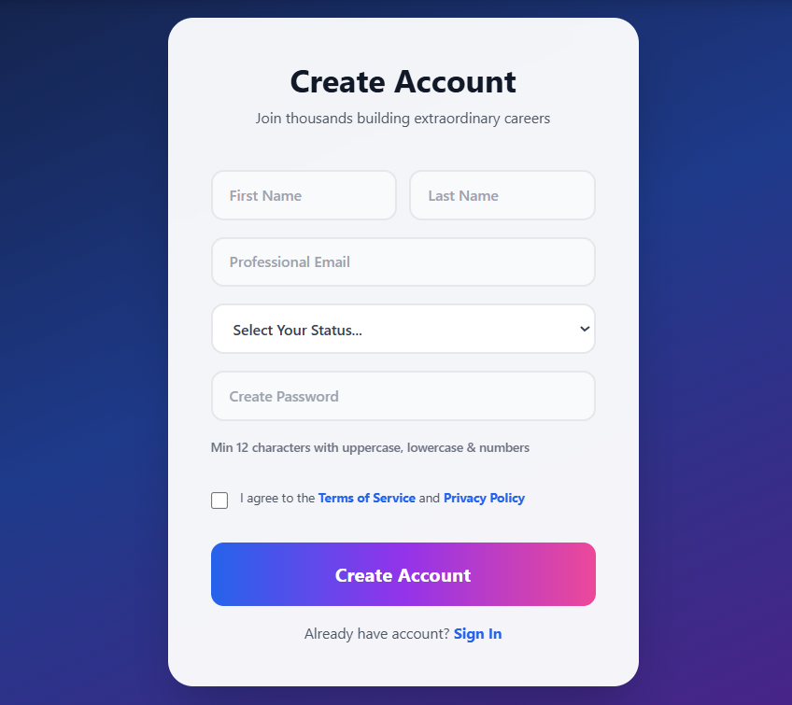

Figure Login Interface (Figure 1):

2.6.2 Profile Creation and Management
Comprehensive profile screens enable users to document educational background, work experience, skills inventory, career aspirations, and learning preferences. Profile information is progressively gathered across multiple sessions rather than overwhelming users with extensive initial questionnaires. Portfolio sections enable users to link or upload work samples, projects, and certifications demonstrating capabilities. Profile visibility settings allow users to make profiles visible to mentors and potential connections for networking opportunities. Edit functionality enables continuous profile updates as users acquire new skills and clarify career goals.
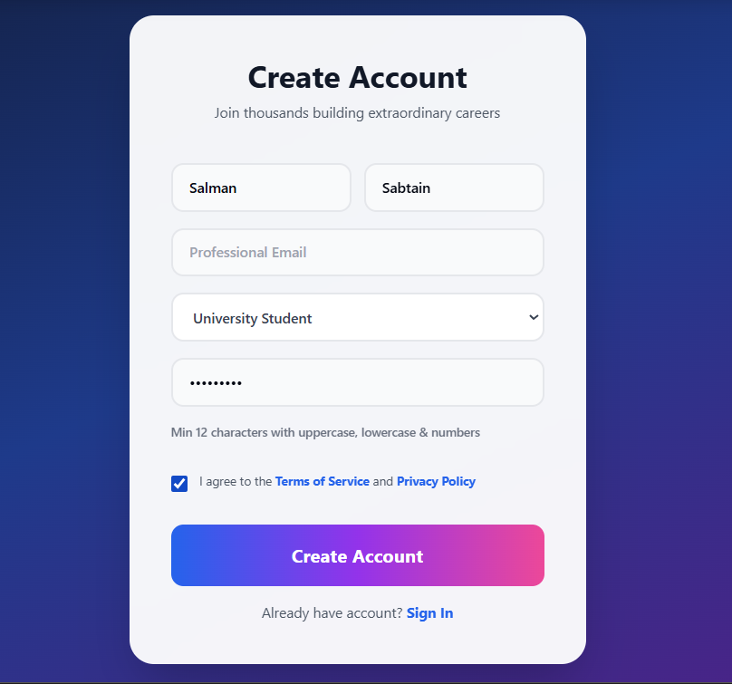

Figure Profile Creation (Figure 2):

2.6.3 Assessment Module Interface
Interactive assessment interface guides users through career preference evaluation, skill self-assessment, learning style identification, and personality indicator questionnaires. Progress indicators show assessment completion percentage, encouraging users to complete comprehensive evaluations. Questions employ clear language explaining relevance to career planning, maintaining user engagement. Results presentation immediately follows assessment completion, providing instant gratification and initial insights. Detailed assessment reports with skill proficiency ratings, career alignment scores, and personalized interpretation support informed decision-making.
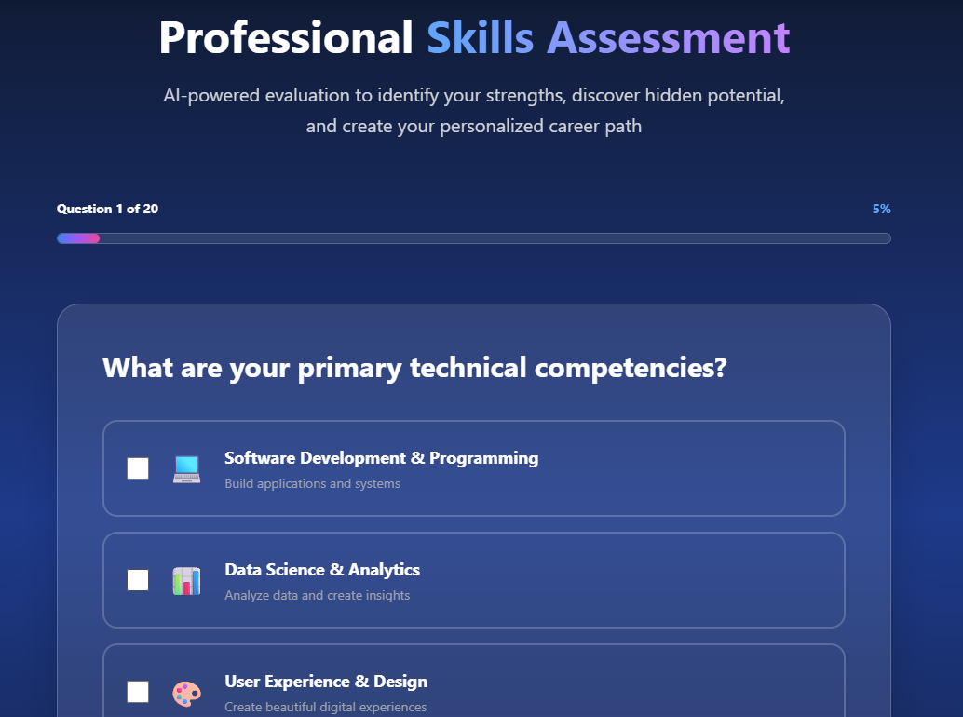

Figure Assessment Module Interface (Figure 3):

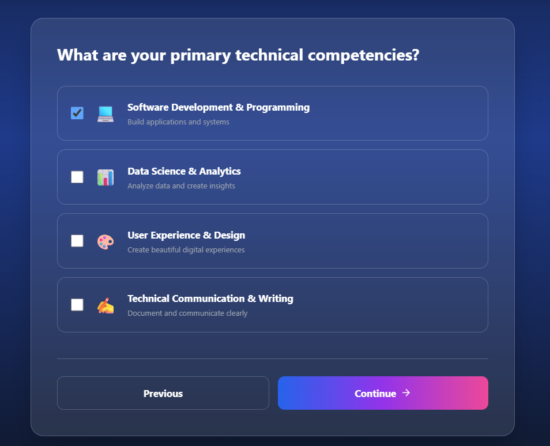

Figure Assessment Module Interface (Figure 4):

2.6.4 Dashboard and Home Screen
Personalized dashboard displays key information including recommended career paths, upcoming learning milestones, newly matching opportunities, and progress summaries. Cards organize information by priority and relevance, enabling users to focus on critical next steps. Recent activity feeds show completed learning activities, earned achievements, and progress updates. Motivational elements celebrate milestones and encourage continued engagement. Shortcut buttons provide quick access to frequently used features including assessment, learning roadmap, and opportunity browsing.

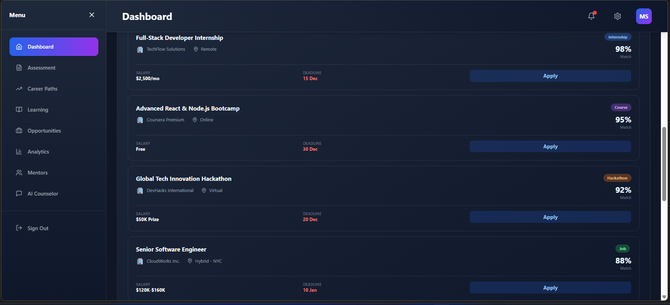

Figure Dashboard (Figure 5):
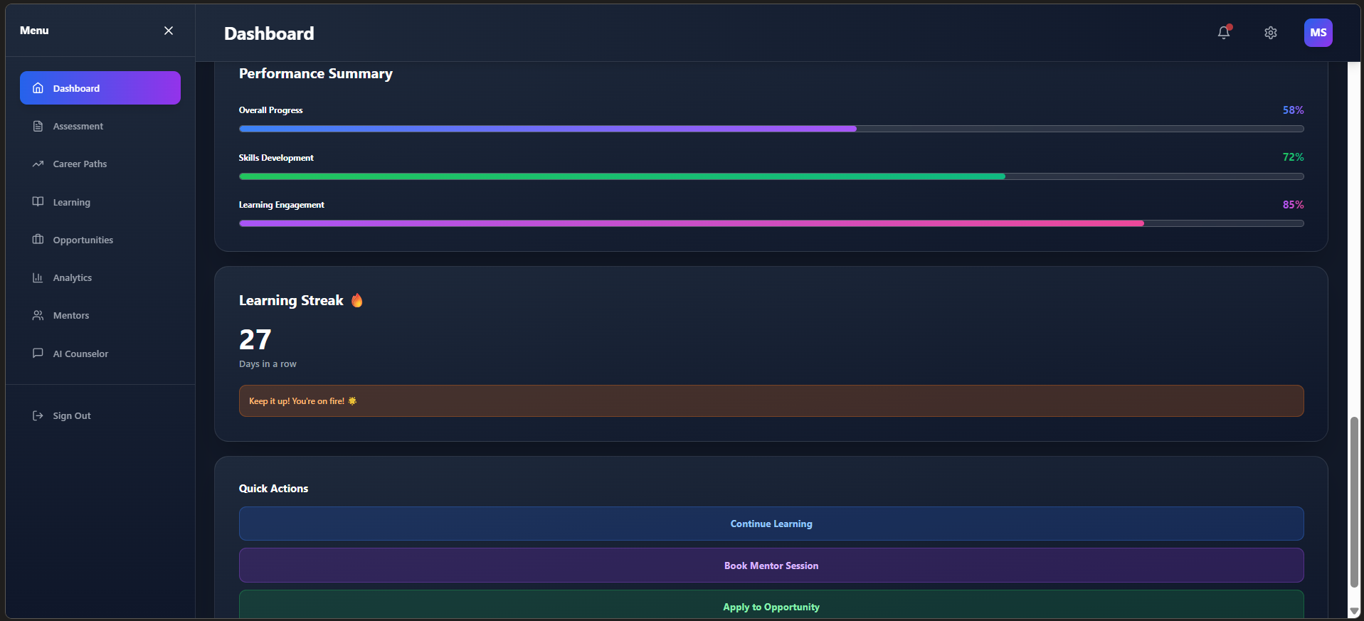Figure Home Screen(Figure 6):

2.6.5 Career Paths Recommendation View
Career paths display multiple potential trajectories with detailed information including timeline requirements, prerequisite skills, salary ranges, job availability, and career progression possibilities. Visual pathway representations show sequential skill development stages and branching possibilities for specialization.
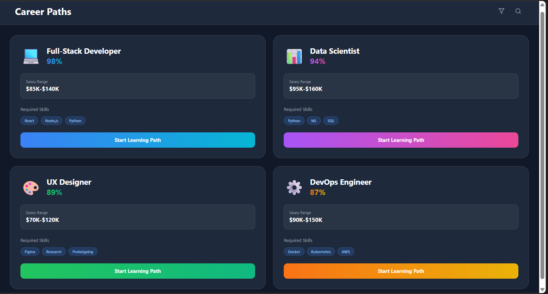

Figure Career Paths (Figure 7):

2.6.6 Learning Roadmap Interface
Learning roadmap visualization displays sequential skill development stages with estimated completion timelines and resource recommendations. Milestone markers indicate skill checkpoints and achievement opportunities. Resource cards show specific courses, tutorials, projects, and certifications supporting each skill acquisition. Drag-and-drop functionality enables users to customize roadmap sequences matching their preferences and schedule constraints. Progress tracking updates roadmap visualization as users complete learning activities, maintaining motivating visual records of advancement.
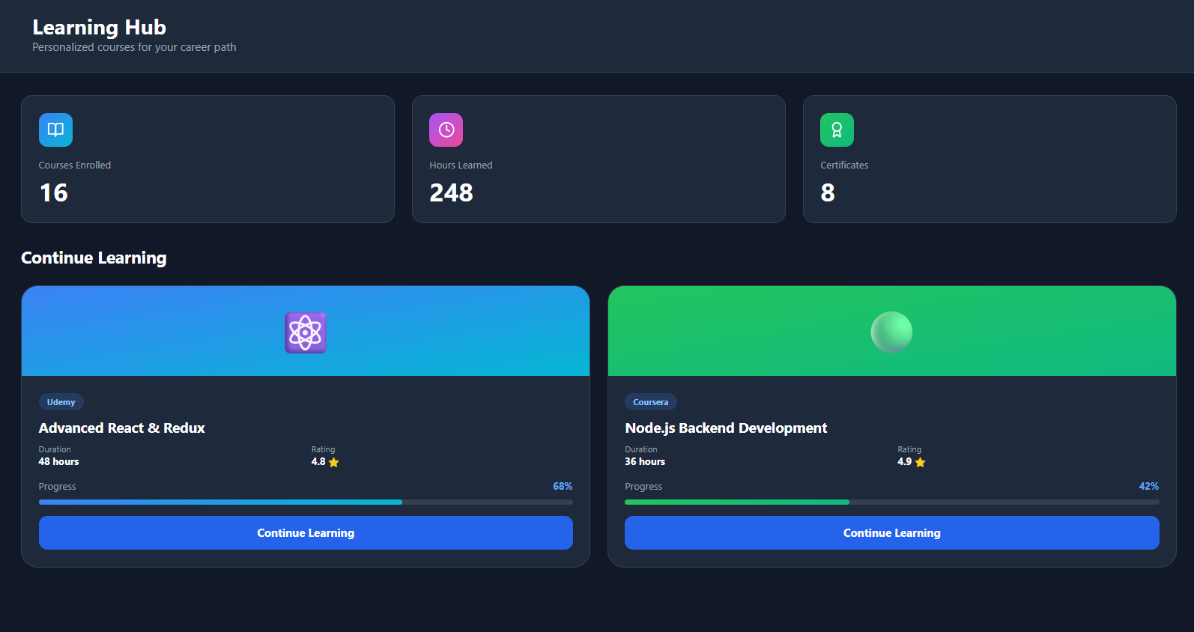

Figure Learning Hub(Figure 8):

2.6.7 Opportunity Listing and Filtering
Opportunity marketplace displays internships, scholarships, hackathons, open-source programs, and jobs organized by career stage, skill requirements, and deadline urgency. Advanced filtering enables searches by opportunity type, location, skill alignment, and time commitment. Personalized recommendations highlight opportunities matching user profiles and learning objectives. Detailed opportunity cards present requirements, application processes, deadline information, and expected outcomes..

2.6.8 Progress Tracking Dashboard
Analytics dashboard visualizes comprehensive skill development data through multiple visualization formats including skill progression graphs, learning hour accumulation, milestone achievement timelines, and goal progress indicators. Comparative analytics show user progress against typical development timelines, providing perspective on advancement rates. Achievement badges celebrate milestone completion, sustaining motivation. Recommendations identify skill acquisition priorities based on career path requirements and emerging market demands. Export functionality enables users to download progress reports for portfolio inclusion or professional communication.

CHAPTER 3:

METHODOLOGY AND SYSTEM MODELING

3.1 Use Case Diagram and Analysis
The use case diagram illustrates interactions between system actors,St udents, Working Professionals, Admins, and the Career Counselling System, across primary functionalities.
Student/Professional Use Cases:
Students and professionals interact with the system to accomplish career planning objectives:
- Register and Login: Create accounts with authentication credentials, establishing system access
- Create/Edit Profile: Document educational background, work experience, skills, and career
- Complete Assessment: Participate in comprehensive skill and career preference evaluations
- View Career Paths: Examine personalized career recommendations with requirements
- Review Learning Roadmap: Access structured learning sequences addressing skill gaps
- Browse Opportunities: Search and filter internships, scholarships, hackathons, and positions
- Track Progress: Monitor skill development, learning completion, and milestone achievements
- Receive Notifications: Access timely alerts regarding opportunity matches and milestones
- Manage Transition: Access career switching features for mid-career changes
- Logout: Securely end system sessions
Admin Use Cases:
Administrative users manage system content and operations:
- Login: Access administrative interface with elevated privileges
- Manage Skills: Create, update, and organize skill taxonomies used and recommendations
- Curate Resources: Review, approve, and organize educational materials in resource library
- Approve Opportunities: Evaluate and activate new internship, scholarship, and job listings
- Monitor Analytics: Access system-wide statistics on user engagement, learning and outcomes
- Manage Users: Handle user accounts, verify information, and address account issues
- Configure Settings: Adjust system parameters, recommendation and notification schedules
- Generate Reports: Create comprehensive reports on system usage and pathway effectiveness.
System Use Cases:
The system independently executes automated functions:
- Generate Recommendations: Analyze user profiles and market data to suggest career paths
- Create Learning Roadmap: Develop personalized learning sequences based on selected careers
- Match Opportunities: Connect users with relevant opportunities through intelligent algorithms
Relationships and Dependencies:
- Assessment completion precedes career path recommendation
- Selected career paths trigger learning roadmap generation
- Profile information combined with assessments enable opportunity matching
- Notifications depend on opportunity matching and milestone achievement
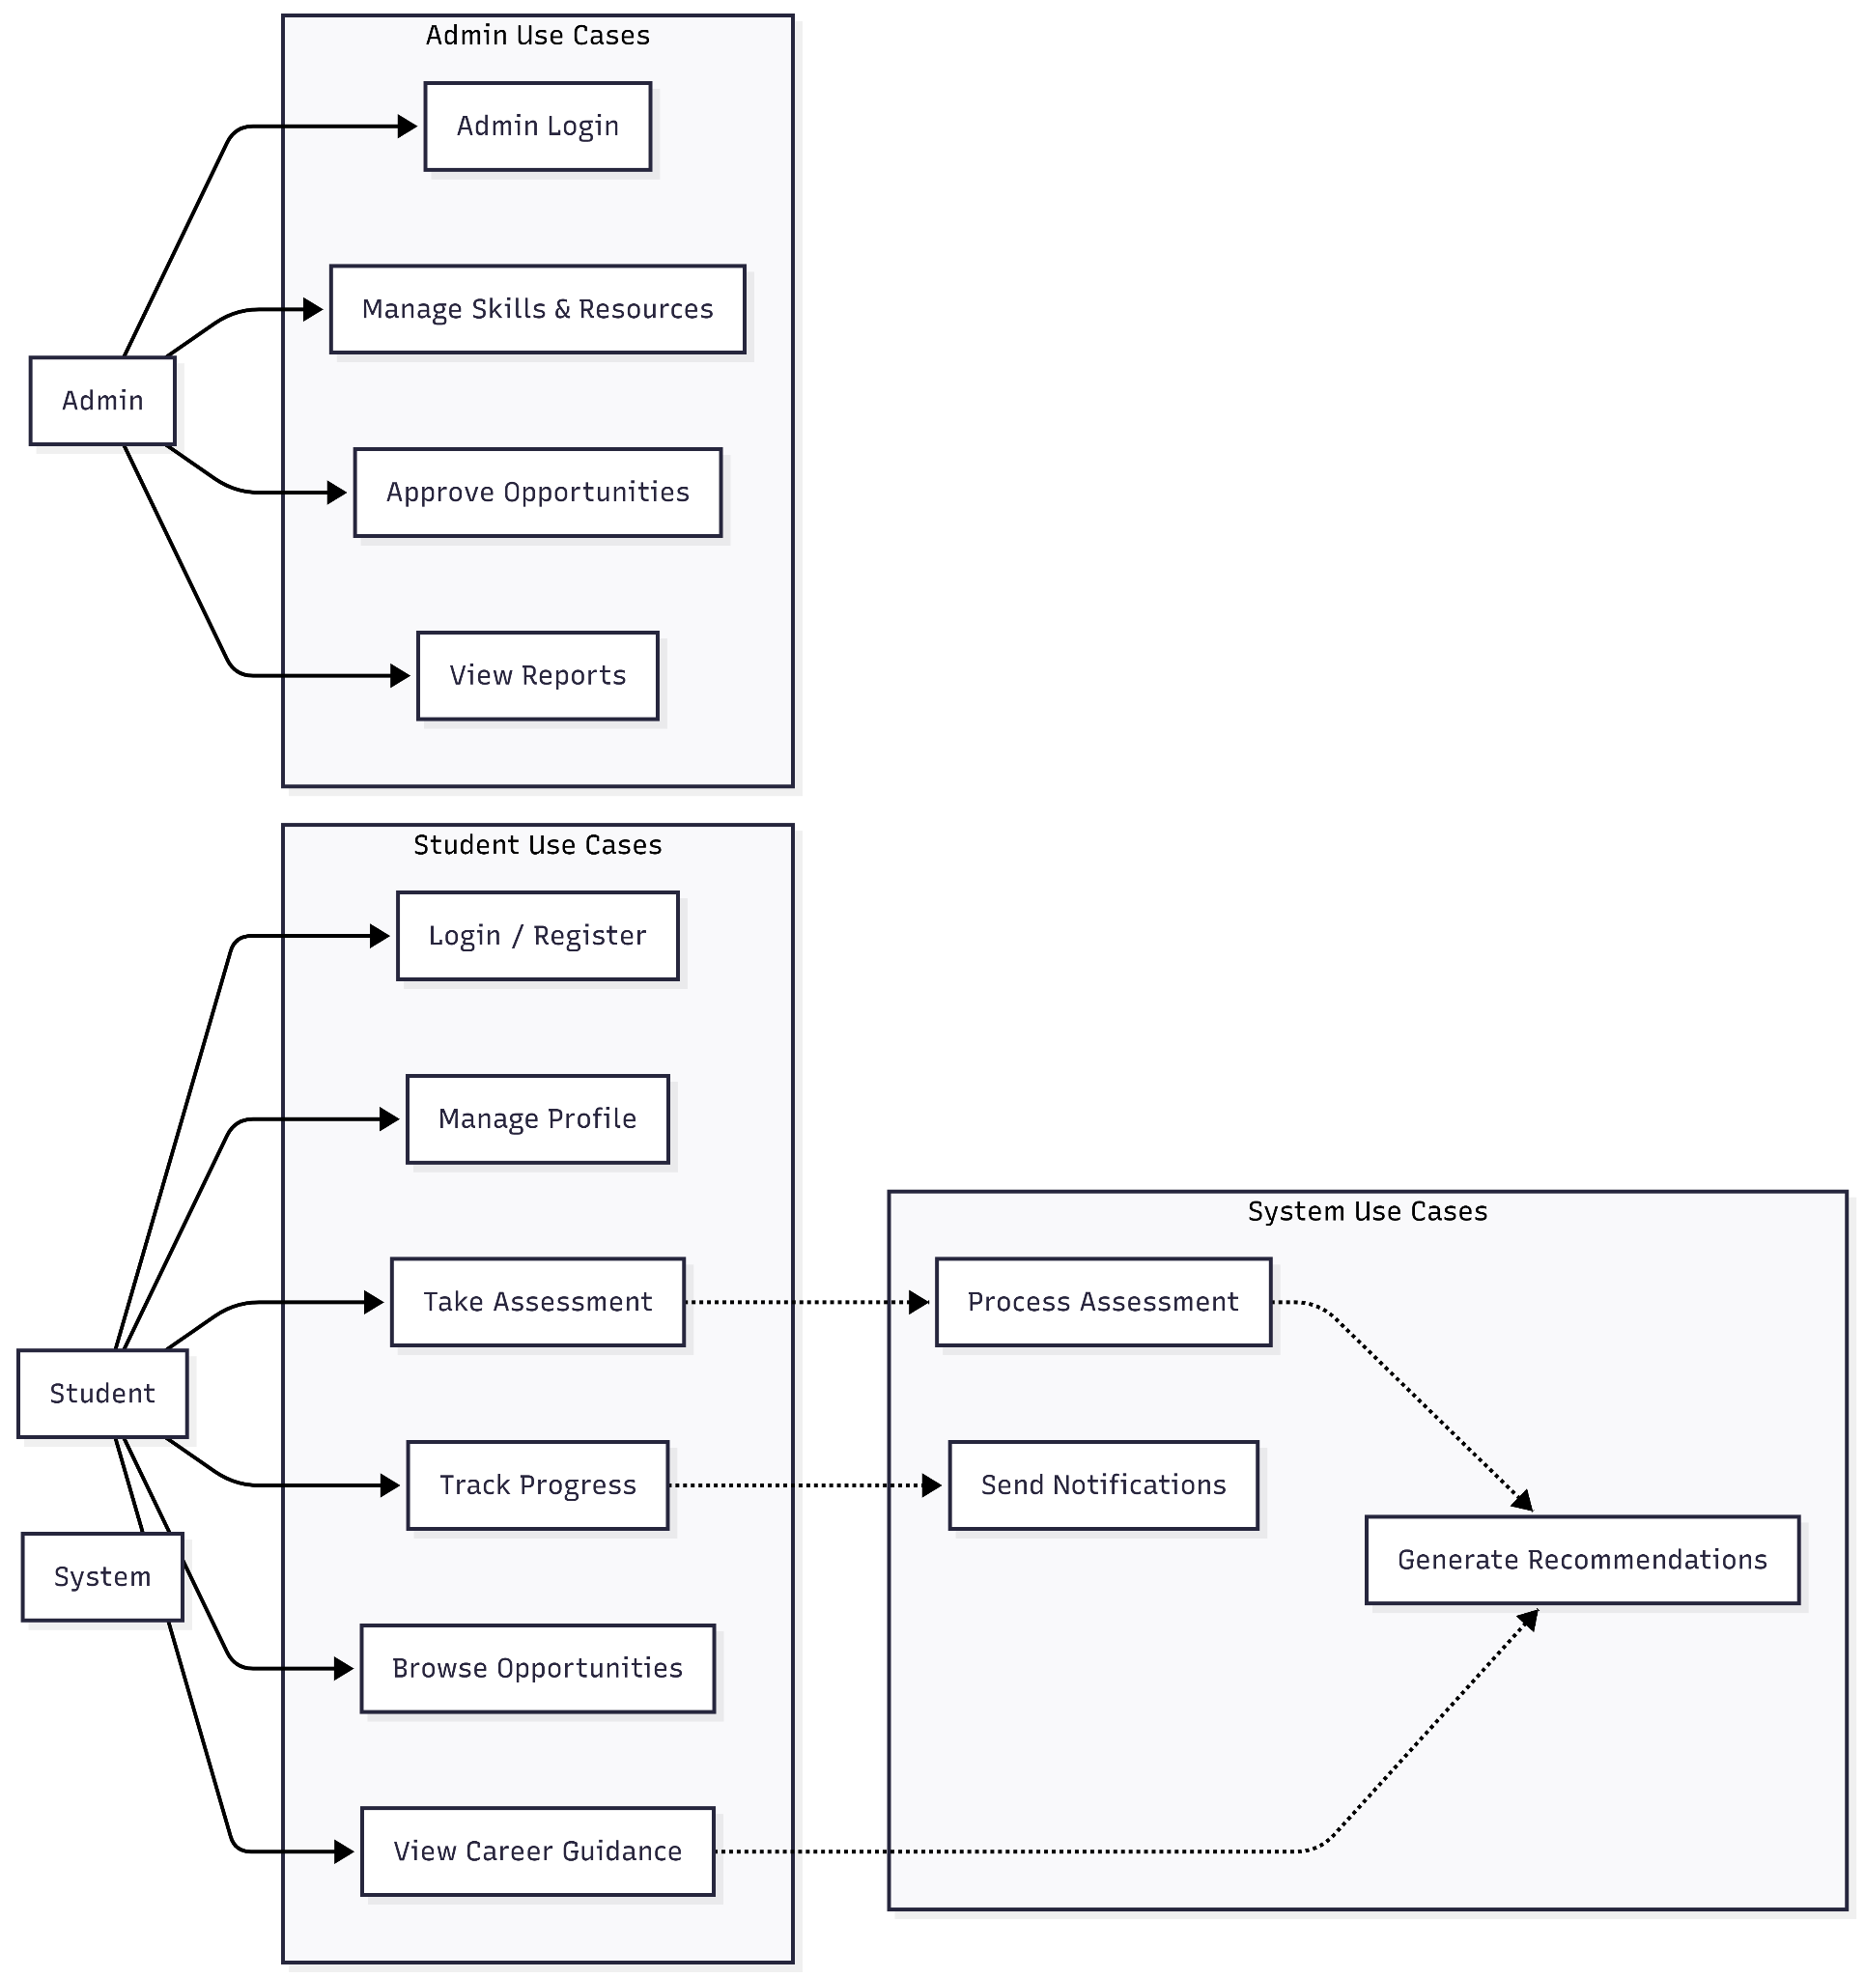

Figure Use Case Diagram (Figure 9):

3.2 Entity-Relationship Diagram
The ER diagram defines data entities and relationships within the Career Counselling system:
Primary Entities:
User: Stores individual account information, authentication credentials, and basic profile data
Profile: Extends user information with educational background, work experience, career stage, and learning preferences
Assessment: Records assessment completion data, scores, and generated insights regarding skills and career alignment
Skill: Represents individual competencies in standardized frameworks with proficiency levels and mastery indicators
CareerPath: Defines career progression options with required skills, education, timeline estimates, and salary ranges
LearningResource: Catalogs educational materials from multiple platforms including courses, tutorials, articles, and certifications
LearningRoadmap: Creates personalized learning sequences combining multiple resources into coherent skill development plans
Opportunity: Records internships, scholarships, hackathons, and positions with requirements and application information
Notification: Tracks system-generated alerts sent to users regarding opportunities, milestones, and learning updates
Progress: Records individual learning activity completion, skill assessments, and milestone achievements
Mentorship: Manages connections between users and experienced professionals providing guidance and networking
Relationships and Constraints:
- One User maintains one Profile with one-to-one relationship
- One User completes multiple Assessments across time
- One User follows one CareerPath with multiple LearningResources
- One LearningRoadmap contains multiple LearningResources
- One Opportunity matches multiple Users through intelligent algorithms
- One User receives multiple Notifications
- One User records multiple Progress entries tracking development
- One Mentor supports multiple Users through Mentorship relationships
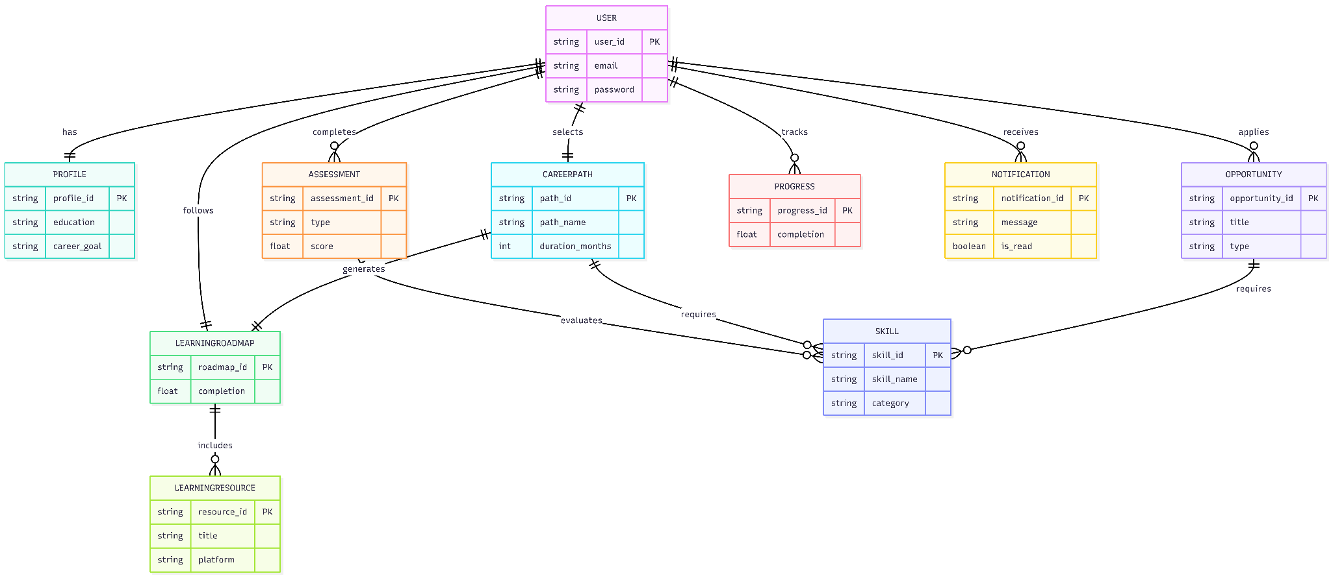

Figure Entity-Relationship (Figure 10):

3.3 Data Flow Diagram
Data flow diagrams illustrate information movement through system processes at multiple abstraction levels.
External Entities:
- User: Provides assessment responses, profile information, and interaction data
- Admin: Manages system content, skills, and opportunities
- External Resources: Learning platforms (Coursera, Udemy), opportunity and data providers
- Notification Channels: Email, SMS, and in-app delivery mechanisms
Data Flows:
- User provides profile data, assessment responses, and learning preferences
- System delivers career paths, learning roadmaps, and notifications to users
- Admin manages system configuration and content
- System connects with external learning and opportunity sources
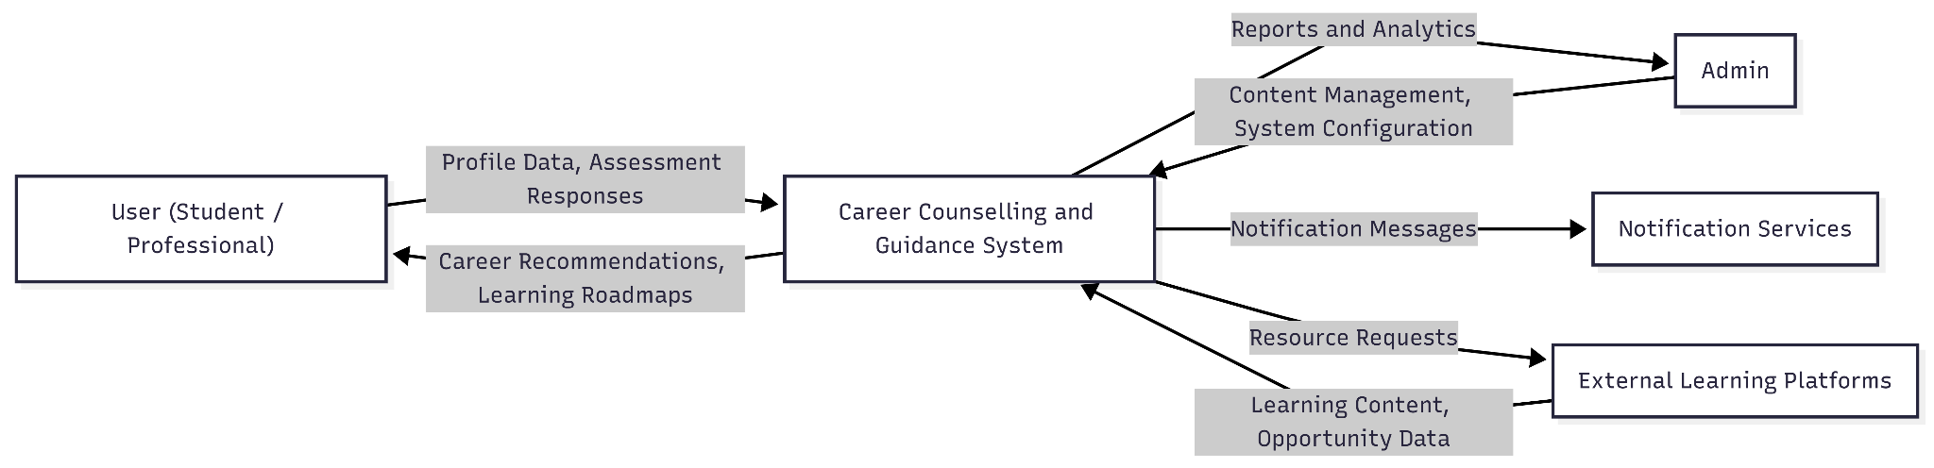

Figure Data Flow Diagram (Figure 11):

CONCLUSION
The Career Counselling and Guidance system successfully delivers a comprehensive, intelligent, and user-centered solution to modern career planning challenges by integrating personalized assessments, AI-driven recommendations, structured learning pathways, and real-time opportunity matching within a unified digital platform. Developed using scalable and secure web technologies, the system demonstrates strong architectural design, reliable performance, and adaptability to diverse user needs, including students, early-career professionals, and individuals undergoing career transitions. By combining data-driven decision support with intuitive user experience design, the platform overcomes the limitations of traditional career counselling methods and provides meaningful, actionable guidance aligned with current labor market demands. The project validates the effective application of artificial intelligence and modern web frameworks in career development systems and establishes a robust foundation for future enhancements such as advanced predictive analytics, mobile integration, and global scalability. Overall, the system contributes significant academic, technical, and practical value by empowering users to make informed career decisions with confidence, clarity, and long-term vision.

Future Work
Although the system achieves its primary objectives, several enhancements can further improve its effectiveness and reach. Future work may include the integration of advanced machine learning models for predictive career analytics, automated resume analysis using natural language processing, and a more conversational AI-based virtual career counsellor. The development of mobile applications, deeper integration with professional platforms such as LinkedIn and GitHub, and support for multiple languages would increase accessibility and user engagement. Additionally, expanding industry-specific career pathways, institutional dashboards, and long-term outcome tracking can enhance value for educational institutions and employers while supporting continuous system improvement.

REFERENCES
Ashish, K., A. S. Rathour, A. Banerjee and B. Machhi. 2024. Digital Career Guidance and Professional Development Platforms. International Journal of Research in Engineering, Science and Management. 7: 112-128.
Bhatti, M. A. and W. A. Alawad. 2024. Optimizing Career Counselling Through Technology: The Role of Digital Platforms in Professional Development. Przestrzeń Społeczna (Social Space). 24: 245-272.
Capito, S. and A. Pergelova. 2023. The Impact of Career Development Apps on Professional Well-being and Career Satisfaction. Journal of Consumer Affairs. 57: 479-506.
Chen, W., M. Rodriguez and S. Patel. 2024. Machine Learning Applications in Career Path Recommendation Systems. IEEE Transactions on Education. 47(3): 234-251.
Choe, J. Y., J. J. Kim and J. Hwang. 2021. Artificial Intelligence in Career Counselling: Merging Technology with Human-Centered Guidance. Journal of Educational Technology Research. 38: 156-178.
Choi, Y. 2013. Digital Transformation in Educational Career Services: A Structural Analysis. Newcastle University. PhD Thesis.
Galvez, E. 2022. Scaling Inclusive Career Development Innovation in Asia and the Pacific. Food & Agriculture Organization Technical Report. 45: 78-95.
Hung, P. 2023. Web-Based Career Development System Using Modern Technology Stack. International Journal of Computer Science and Engineering. 15(4): 203-218.
Jackson, E. 2021. Evolution of Career Counselling: From Traditional Methods to Digital Platforms. Career Development Quarterly. 45(2): 134-156.
Li, C., M. Mirosa and P. Bremer. 2020. Digital Career Guidance Platforms and Their Impact on Professional Development Outcomes. Sustainability. 12(18): 5528-5545.
Madinga, N. W., J. Blanckensee, L. Longhurst and N. Bundwini. 2023. The New Normal: Digital Adoption in Career Guidance Services. European Journal of Management Studies. 28(3): 175-192.
Mahardika, F. and R. B. B. Sumantri. 2024. Implementation of Secure Payment Gateway in Web-Based Career Counselling Applications. Journal of Innovation Information Technology and Application (JINITA). 6(2): 64-77.
Mai, X. T. and T. Nguyen. 2024. Understanding Users' Trust in Digital Career Counselling Platforms: A Study of Transfer Mechanisms. Journal of Hospitality and Education Technology. 15(1): 89-104.
Mathur, V. and S. Arora. 2020. Digital Transformation in Educational Career Services. PHI Learning Pvt. Ltd. New Delhi, India.
Memon, M. A. 2014. Technology-Enabled Career Planning in Educational Supply Chains. Institut National Polytechnique de Toulouse-INPT. Technical Report.
Miao-Mentor, X. 2024. Career Development and User Experience Design Principles. Technology and Learning Lab. 18(4): 156-174.
Misra, N., Y. Dixit, A. Al-Mallahi, M. S. Bhullar, R. Upadhyay and A. Martynenko. 2020. Artificial Intelligence, Big Data, and Machine Learning in Career Development Systems. IEEE Internet of Things Journal. 9(12): 6305-6324.
Pavan, M., M. V. Sarma, S. Mutreja, H. Raj and M. Staffi. 2021. Smart Career Counselling Platform: An Interactive System for Professional Development. International Journal of Research in Engineering, Science and Management. 4(8): 85-102.
Peng, B., M. Erkoc and V. Omachonu. 2024. Digital Career Counselling and Professional Guidance: A Study on Effectiveness and User Satisfaction. Journal of Educational Technology and Innovation. 55(2): 112-128.

